**Tableau Report Writing**

**Analysis On AirBnB**

**Airbnb, Inc. ,** based in San Francisco, California, operates an [online marketplace](https://en.wikipedia.org/wiki/Online_marketplace) focused on short-term [homestays](https://en.wikipedia.org/wiki/Homestay) and experiences. The company acts as a [broker](https://en.wikipedia.org/wiki/Broker) and charges a [commission](https://en.wikipedia.org/wiki/Commission_(remuneration)) from each booking. The company was founded in 2008 by Brian Chesky, Nathan Blecharczyk, and Joe Gebbia. Airbnb is a shortened version of its original name, AirBedandBreakfast.com. The company has been the subject of criticism for lack of regulations and enabling increases in home rents.

The dataset we chose is downloaded from github and then we imported it in to the tableau desktop. Then we are going to perform the visualization using the chosen data.

The analysis for the first dashboard

**DASHBOARD 1**

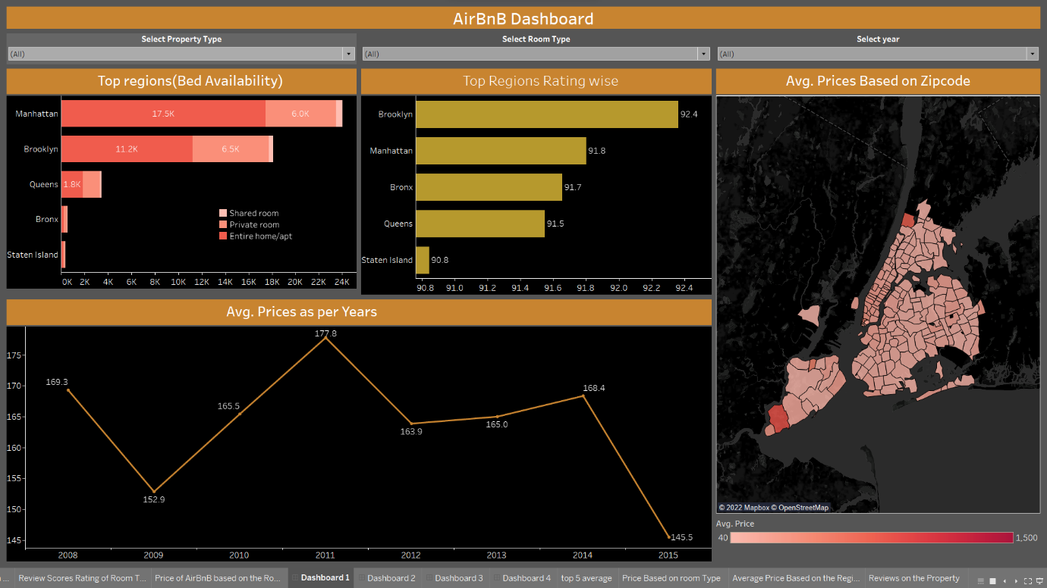

For the first visualization we analyzed the top region(bed availability) through using the horizontal bar chart by that visualization we can know that Manhattan with highest number of beds availability that is 17.5k entire apartment,6.0k private rooms and 600 shared room and the lowest beds availability in the region is Staten island with 0.2k entire home,0.1k private room and 0 shared roomed beds so, we can know that Staten island has no shared room beds available so we can conclude that Manhattan has highest beds availability by comparing to the remaining regions.

By the second visualization we are going to visualize the top regions rating wise using horizontal bar chart. Brooklyn has the highest average rating with 92.4 and Staten Island has the lowest average rating that is 90.8.

By the third visualization we are comparing the Avg.price over the years using the line chart that the highest average price is recorded in 2011 that is 177.8 dollars and lowest average price is recorded in 2015 that is 145.5 dollars.

The last visualization in the dashboard is avg price based on zip code by using maps the highest average price is recorded in the zip code 10309 in Staten Island that is 850 dollars and lowest average price is recorded in the zip code 11423 in queens that is 44 dollars only.

**DASHBOARD 2**

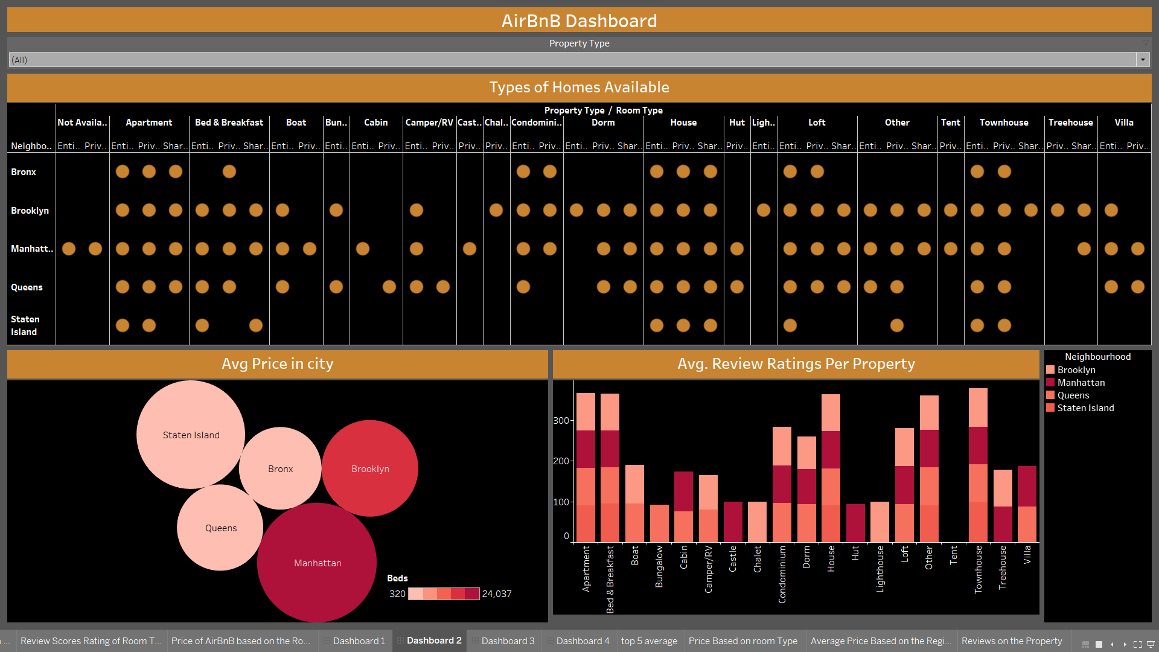

The first visualization of second dashboard is indicating the types of homes available in the neighborhood of the New York city using the heat maps by the heat maps we can see that Manhattan has the highest type of homes available compared to the remaining region whereas Staten Island has least type of homes available across the neighborhood.

In the second visualization we are comparing the average price in the city using the bubble chart. By visualization we know that Manhattan has the average price across the region that is $198.5 and 24,037 beds available whereas Bronx has the least average price across the region that is 94.7 and 547 beds availability.

In the third visualization we are comparing the average review rating per property by using stacked bar chart the highest average rating on the property is the castle property with 100 average rating and the lowest average review rating with 75 rating.

**DASHBOARD 3**

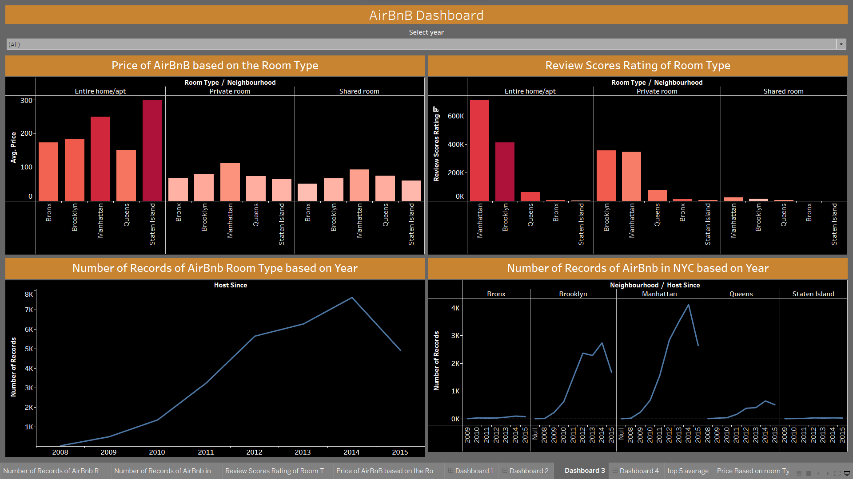

The first visualization we comparing average price across the room type in the region the Staten Island has the highest average price that is $295.7 in the entire room type and the Manhattan has the highest average in private room type that is $111.0 and the Manhattan has the highest average price in the shared room that is $92.4.

In the second visualization we comparing the review rating across the room type. Manhattan has the ratings in entire room type with over 700k ratings and Brooklyn has highest rating with 355k ratings and the Manhattan has the highest rating in shared room with 25k.

In the third visualization we are going to compare the numbers of records recorded over the years using line chart the highest number of records that are recorded in the year 2014 that is 8k

In the fourth visualization we are comparing the highest records across the neighborhood that is Manhattan has the records in the region with 4119 records in 2014 and the Staten Island has the least records over the years.

**DASHBOARD 4**

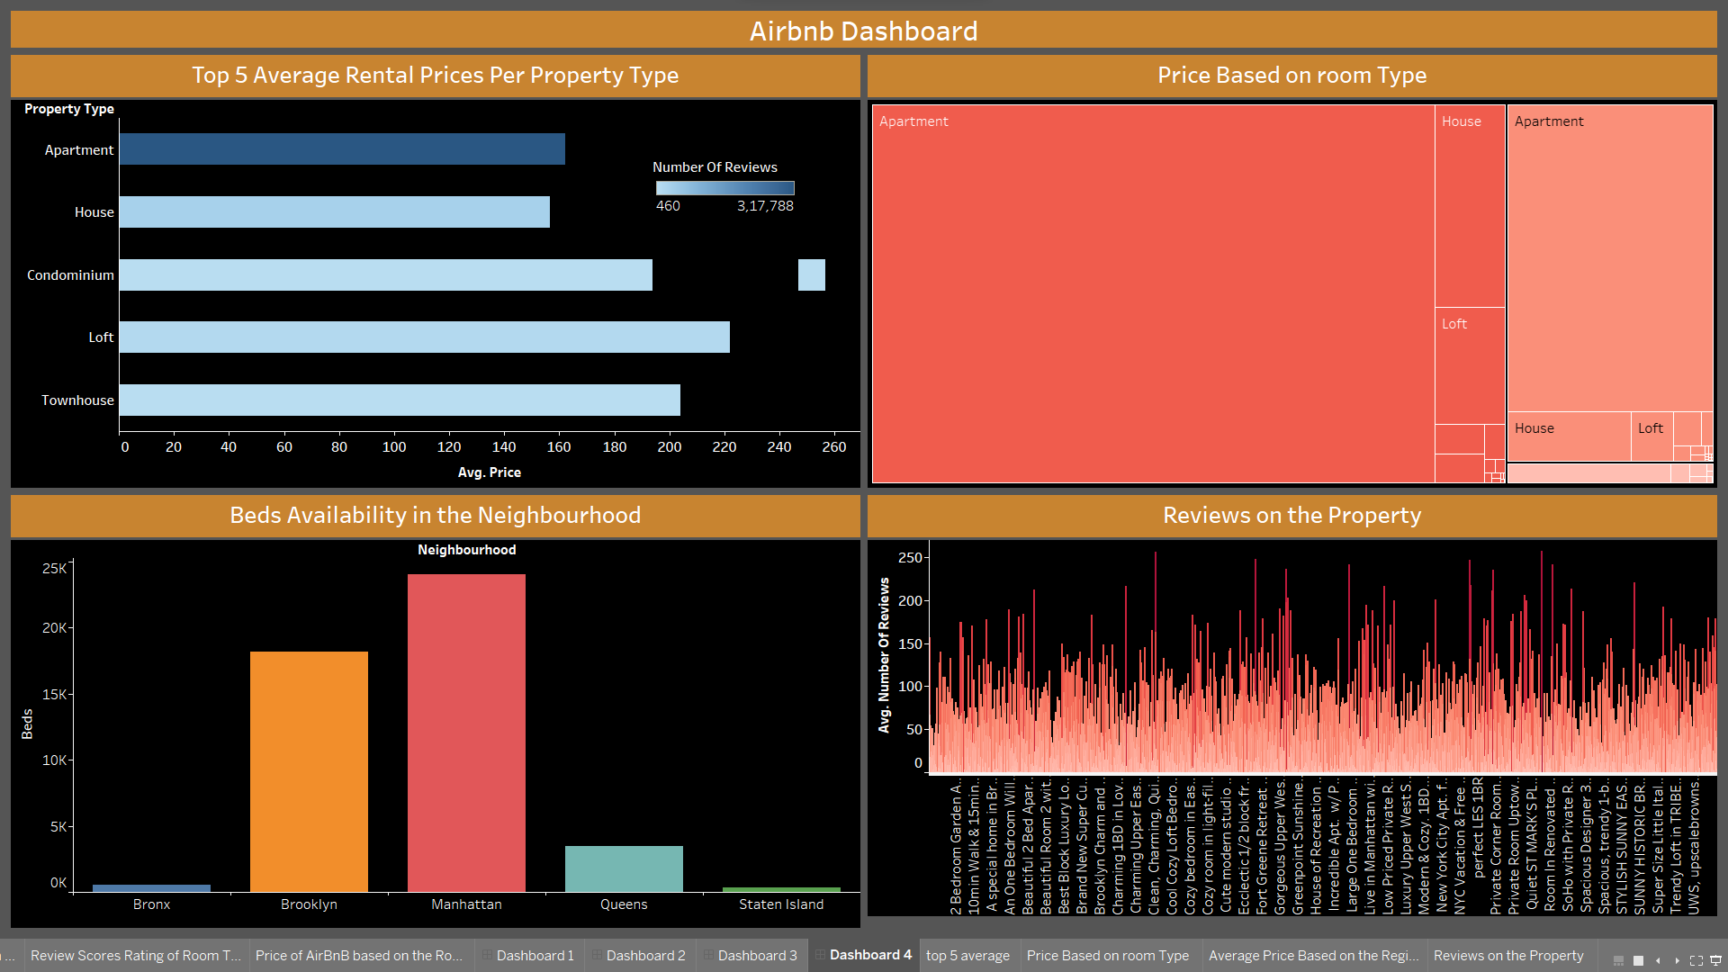

In the first visualization we took the top 5 average price per property by using horizontal bar chart among them condominium has highest average price $256 followed by loft and townhouse.

In the second visualization we used tree maps we can see most of the part occupied by apartment based room price and least occupied by shared room prices

In the third visualization we used bar chart to compare the beds availability that Manhattan has the highest number of beds availability that is 24037

In the last visualization we compared the average number of reviews among the properties that the roof top room in Williamsburg that is highest rated with 257 rating.

**CONCLUSION:**

By this analysis we conclude that Manhattan in the New York has the highest number of income generations and property availability due many reasons that the most of the people in the united states move to New York city for the better job opportunities and high paid jobs and most iconic companies are situated Manhattan so, most people interested to move in to Manhattan neighborhood.